ALCO-SENSOR IV / RBT IV
STUDENT HANDOUT for PROFICIENCY TRAINING

- Students, you must demonstrate your proficiency on your device by conducting seven (7) mock tests in accordance with 49 CFR Part 40.
- You must show that you are able to respond to your devices messages and know what actions to take in the event of an error message or malfunction.
- All tests and procedures must be technically correct.
- You must know how to run an air blank and what the purpose of an air blank is.
- You will be taught how to perform external calibration checks (accuracy checks) and properly keep the log book for your device.
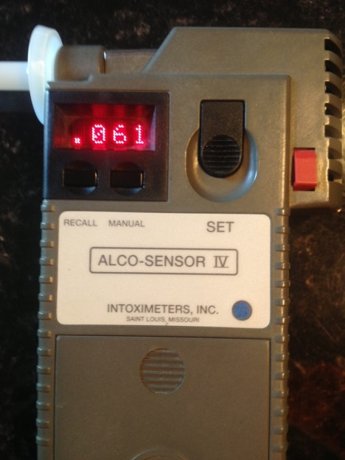
The Alco-sensor IV uses a FUEL CELL to detect alcohol. This is also called an electrochemical oxidation sensor.

Alco-sensor IV Display Messages

MESSAGE | MEANING
BAT | The 9-volt alkaline battery needs replacing. If you see the BAT message, but the instrument thereafter continues normal operation, you may complete the current test. If you see the BAT message followed by VOID, you must replace the battery before continuing.
BLNK | Indicates the instrument is running an air blank. This procedure samples the chamber to ensure it is free of alcohol.
CAL | Seen only during a calibration procedure. ‘CAL’ will flash on the screen to indicate that the sample should be introduced.
CHEK | Seen only during an external calibration check (accuracy check) procedure. ‘CHEK’ will flash on the screen to indicate the instrument is ready for the sample to be introduced.
CONF | This message will flash when it is time for the subject to provide a breath sample for a Confirmation Test, and only when the AS IV is connected to the RBT IV.
MAN | The operator must take a manual sample. The breath flow sensor is inoperative and normal automatic sampling will not function. If the display says ‘MAN’, you must take manual samples only until the instrument is sent to Intoximeters for repair.
NOGO | This message will flash after an insufficient breath sample is provided. After TEST, SCRN, or CONF appears again, instruct the subject to provide another sample. They will be given three (3) chances to blow before the instrument voids. The first two insufficient attempts will be followed by the message NOGO. The 3rd attempt will VOID.
RFI/VOID | Radio Frequency Interference. RFI has been detected and will prevent a valid test. Eject the mouthpiece and start over.
SCRN | (Flashing). Indicates the subject should provide a breath sample for their screening test.
SET | The operator should press the SET button whenever this message is flashing. This occurs after the instrument has taken a sample of breath. Pressing SET will close the sampling chamber after a test.
TEMP > or TEMP < | Temperature of the device is too high or too low. Must be between 10 – 40 Celsius.
TEST | TEST will flash when the AS IV is ready for a breath sample, but this message should only be seen when using the AS IV alone – not when connected to the RBT IV. If TEST is seen, the AS IV is not communicating with the RBT IV, and you will not get a printout, countdown timer after a positive, etc.
VOID | Indicates an improper testing condition. Eject the mouthpiece and start over.
WAIT | The device is preparing for a test or procedure. If WAIT is displayed for more than 1 minute, turn the unit off and wait several minutes before trying again.
><>< | Indicates the instrument is running a self-diagnostic test. Wait for the next message. Do not have the subject blow when you see this.
+ | Indicates the device has detected breath flow.
++ | Indicates the subject has provided the minimum breath flow (1200 cc)
>400 | The test result exceeded the maximum reading capability of the instrument (over 0.400)

ALCO-SENSOR IV VOID CODES & MESSAGES

VOID CODE | DISPLAY/ PRINTOUT | PROBLEM | SOLUTION
01 | BAT | Battery too low for use | Replace 9-volt alkaline battery
02 | VOID or VO02 | SET button was not depressed at the time of sample given | Remove mouthpiece and start test over
04 | VOID or VO04 | Valve did not take sample | Low battery voltage. Replace battery.
05 | VOID or VO05 | 180 second time-out | You waited too long to submit a sample. Remove mouthpiece and start over.
06 | VOID or VO06 | Three (3) insufficient samples were provided | Either document the Insufficient Sample appropriately or start over – new mouthpiece, new test; if you will give more than 3 tries.
07 | >>>>>VOID or VO07 | No alcohol or too much alcohol during calibration | Contact Intoximeters’ service dept. A technician must inspect the device.
08 | VOID or VO08 | SET button pushed too soon (while the device was analyzing the sample) | Remove mouthpiece and start over. (Note: Do not press the SET button until prompted to do so.)
09 | TMP< VOID or VO09 | Temp too low for test | Warm up the device
10 | TMP < VOID or VO10 | Temp too high for test | Cool down the device
11 | VOID or VO11 | High air blank (> 0.000) | Remove mouthpiece, wait a few minutes, and try again.
12 | RFI! VOID or VO12 | RFI detected that could affect the test | Remove mouthpiece. Remove source of potential RFI, begin again.
14 | VOID or VO14 | Voided analysis | Remove mouthpiece. Wait a few minutes, and try again. If VOID 14 continues, a Certified Calibration Technician should calibrate the device and perform an accuracy check before resuming testing. If problem persists, contact Intoximeters’ service dept.

- Automatic sampling. The AS IV requires a minimum breath volume of ___________ ccs.
- When the device senses adequate breath flow, the operator will see a __________ ___________ (+) on the screen.
- When the subject meets the minimum breath volume, you will see __________ ____________ _____________ (++).
- The message ________________ indicates an insufficient sample.
- You will see the ___________ message twice, followed by ________________ on the 3rd insufficient sample.
- An external calibration check is also commonly called an __________________ ____________________.
- The gas value for accuracy checks ___________ g/210L.
- The tolerance range on an external calibration check (accuracy check) is plus or minus ____________.
- QAP = _________________ _______________________ _______________.
- Accuracy checks should be performed a minimum of every _______ days.
- On the RBT IV, to start a screening test, press the ______ key.
- On the RBT IV, to start a confirmation test, press the ______ key.
- On the RBT IV, to start an accuracy check, press the ______ key.
- On the RBT IV, to start a calibration procedure, press the ______ key.
- Only a __________________ ___________________ __________________ __________________________ may calibrate the device.

